Chapter 19, Solution 30.

- Convert to z parameters; then, convert to h parameters using Table 18.1.
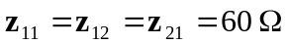, 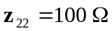

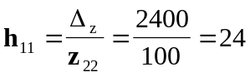, 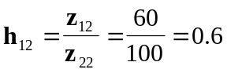
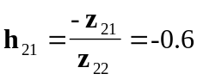, 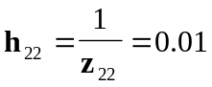

Thus,
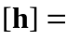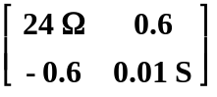

- Similarly,
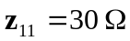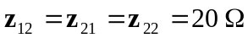

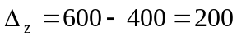

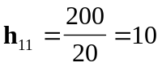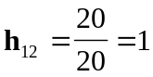
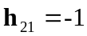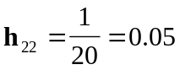

Thus,
